**3D Viewer Application**

This Graphics viewer is developed in WPF using following libraries

1. SharpGL
2. SharpGL.SceneGraph
3. SharpGL.WPF

This project is developed in Visual Studio 2012 verision.

**Code repository**

The code is available in the github. Please use git url - <https://github.com/alagezanmk/3dViewer.git> to clone the code in a new folder.

Git Command: **git clone** [**https://github.com/alagezanmk/3dViewer.git**](https://github.com/alagezanmk/3dViewer.git)

**How to run**

1. Open git folder 3DViewer/3DViewer
2. Double click the 3DViewer.sln to open Visual Studio
3. Select the Build -> Build solution
4. Check the build is successful
5. To run - select the **Debug -> Start without or Start without Debugging**

**Application**

1. Application GUI

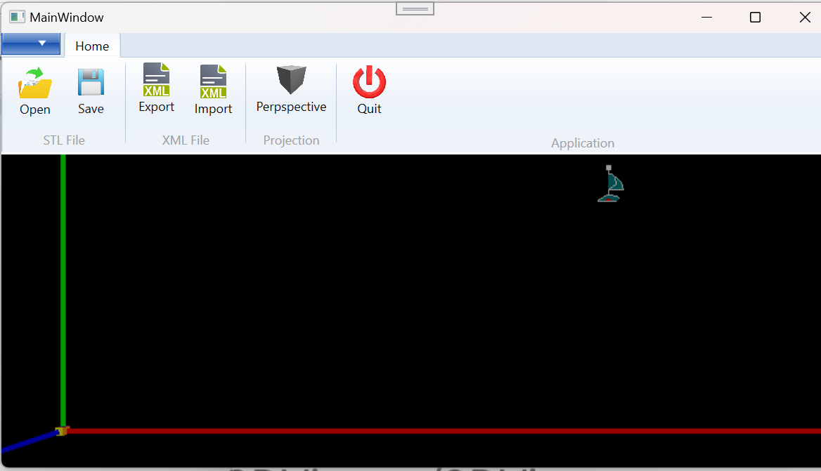

1. Open the **stl file** by click Open icon



1. Application will show the load model as

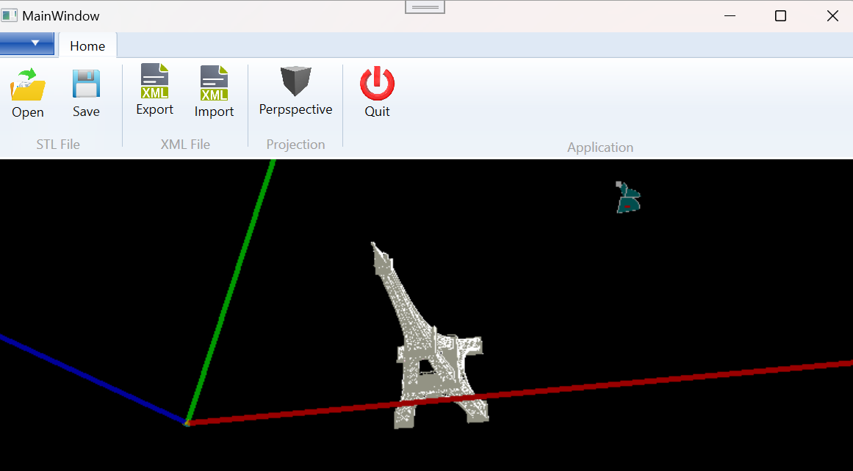

1. The following icons are for STL files methods
   1. 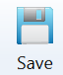 - to save as Binary STL File
   2.  to export open STL File as XML Format file
   3.  to import STL Model in XML Format
2. The Icons 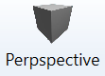 and 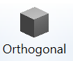 can be clicked to switch between **Perspective and Orthogonal** Projections
3. Catia Compass is drawn in view



1. Zoom, Pan and Oribit
   1. Use **Mousewheel** to **Zoom in/out**
   2. Click **Left Mouse button** and move to **Pan**
      1. Press **Control Key** to **Pan Depth in/out**
   3. Click **Right Mouse button** and move to **Oribit**
      1. Press **Control Key** to **Oribit in Z angle**

The below are not available due Hit test is not implemented - not perfect with SharpGL OpenGL

1. Select and Unselect
2. Catia Compass is Drag and drop